PAIR Platform
Design Document – TalentBridge Platform

Project Name | PAIR – TalentBridge Platform
Document Type | Design Document
Version | v1.0
Status | Draft – To be reviewed and validated with client/stakeholders
Date | April 2026

1. Design Purpose
This document describes the process and interaction design for the PAIR platform, focusing on:
- Talent profile and artifact upload
- Recruiter discovery, review, and expression of interest
This document complements the Functional Requirements document and translates them into a solution architecture diagram, process models (BPMN), and screen-level user flows (wireframes).
The design approach follows the software architecture documentation practices outlined by Bass, Clements & Kazman (2012), which recommend separating architectural views (structural/deployment) from behavioural views (process flows and interaction design) to provide a complete picture of system design.
2. Scope of This Design
In Scope
- Solution architecture and deployment design
- Talent upload and publish flow
- Artifact verification status flow
- Recruiters browse, view, and "Interested" action
Out of Scope
- Infrastructure setup details
- AI implementation details
- Future features (chat, matching, analytics)

3. User Roles
Role | Description
Talent | Creates profile and uploads verified project artifacts for recruiter discovery.
Recruiter | Creates profile, browses projects, reviews artifacts, and expresses interest in talents.
Admin | Verifies uploaded artifacts and manages user accounts on the platform.

4. Solution Architecture
The solution architecture diagram below illustrates the layered structure of the PAIR platform, showing how the presentation, authentication, application, data, and infrastructure layers interact. This view follows the layered architecture style described by Bass, Clements & Kazman (2012), which organises system components into distinct layers where each layer only communicates with the layer directly below it, supporting separation of concerns, security, and maintainability.

4.1 Architecture Overview
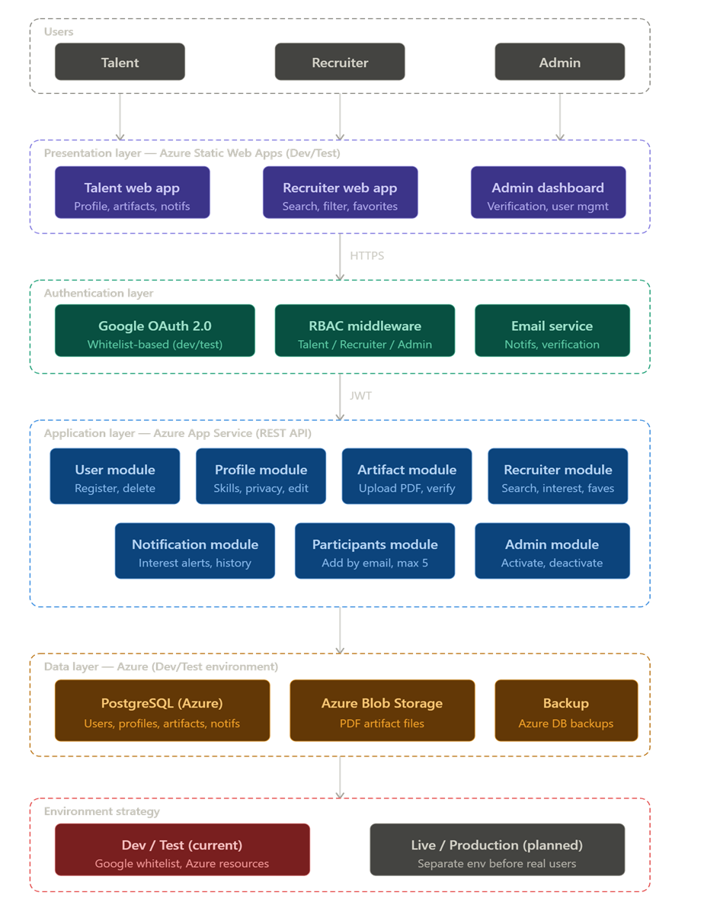
Figure A: PAIR Platform Solution Architecture – Azure Deployment

4.2 Architecture Layer Descriptions
The architecture is organised into five layers, each with a distinct responsibility:
Layer | Description
Presentation Layer  (Azure Static Web Apps) | The web interface that users interact with. Separate views are provided for Talent, Recruiter, and Admin users. No business logic is processed in this layer — it only displays data and sends user actions to the API.
Authentication Layer  (Google OAuth 2.0 + JWT) | Manages user identity and access. Supports both email/password login and Google OAuth 2.0. Whitelisted Google accounts are used in the Dev/Test environment. Role-Based Access Control (RBAC) enforces what each user type can do. JWT tokens are issued after successful authentication.
Application Layer  (Azure App Service – REST API) | Contains all business logic, organised into modules: User, Profile, Artifact, Recruiter, Notification, Participants, and Admin. The API processes requests from the frontend and communicates with the data layer. This layer never communicates directly with the frontend storage.
Data Layer  (Azure PostgreSQL + Blob Storage) | Stores all structured data (users, profiles, artifacts, notifications) in PostgreSQL. PDF artifact files are stored separately in Azure Blob Storage, with only references stored in the database. A backup service handles scheduled database backups.
Infrastructure Layer  (Microsoft Azure) | Hosts all platform resources on Microsoft Azure. Two environments are maintained: Dev/Test (current) and Live/Production (to be set up before onboarding real users, FR6.3).

4.3 Environment Strategy
The platform maintains two separate environments in accordance with FR6.2 and FR6.3:
Environment | Status | Description
Dev / Test | Current | Used for development and testing. All Azure resources are hosted in Australia East region. Australia East was selected as it provides full Azure service availability. Note: initial resources were in Australia Central (free tier) and have been migrated to Australia East.
Live / Production | Planned | To be configured separately on Azure before onboarding real users. Recommended region: Australia East. Future backup/disaster recovery site: Australia South East (Melbourne).

5. Business Process Design (BPMN)
Business process flows are modelled using Business Process Model and Notation (BPMN) 2.0 (OMG, 2011). BPMN provides a standardised graphical notation for documenting end-to-end business processes, making them accessible to both business stakeholders and the development team. Each process below illustrates how users and the system interact to complete a key platform workflow.
5.1 Process 1: User Creates Account
Process Description:
- The process starts with the user opening the website.
- For this process it is assumed that users do not have login credentials yet, so they choose to create a new account.
- Decision: create account as a Talent or a Recruiter.
- Either decision leads to entering their respective details followed by entering their email and password.
- After submitting, the user must verify their email and then their account is successfully created.
- If the account already exists, the system will lead the user back to the login page with a message prompting them to try logging in.
- If the user does not click the sent verification email, the process will end with the application expired.
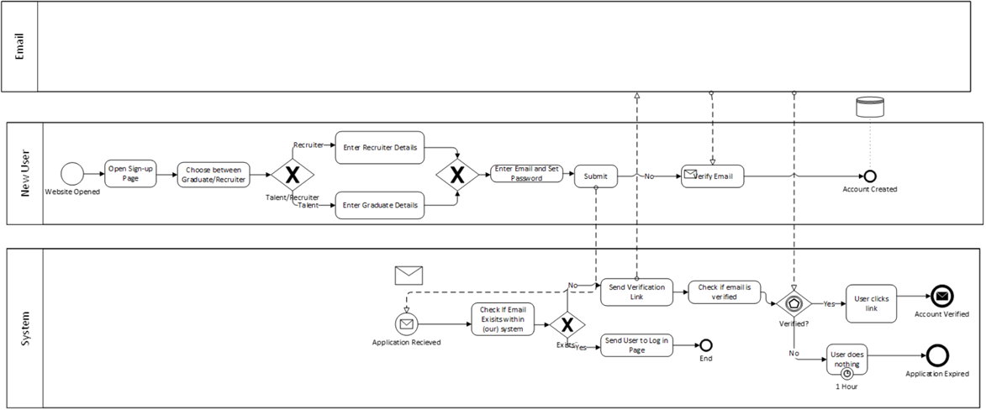

Figure B: BPMN – Process 1: User Creates Account

5.2 Process 2: User Log In
Process Description:
- The process starts with the website open and then user will proceed to enter their email and password.
- The system will check if the inputs are correct, if yes, the user is successfully logged in.
- If the inputs are incorrect users will be shown an error message and then prompted to try again.
- Users then try to input their email and password again or click “forgot password” which will lead them to password recovery process.
- If user chooses not to do anything, the process is terminated.
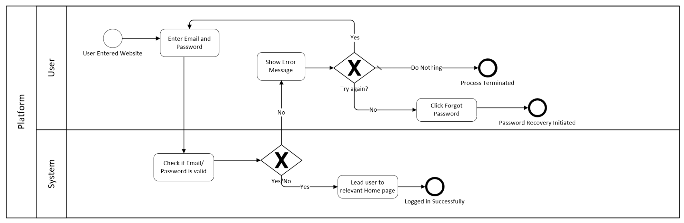
Figure C: BPMN – Process 2: User Log In

5.3 Process 3: Artifact Upload & Verification
Process Description:
- The process starts with talent already being logged and then navigate towards “upload work”.
- Talents are then required to fill in information on the project such as name, classification tag up to 3, description.
- They will have to then select the PDF file, by default users will only be able to select a PDF file type.
- Finally, the process is finalized when “create project” is clicked.
- The system will then have the artefact appear in the admin’s dashboard from which they can accept or reject the work to be shown in the platform.
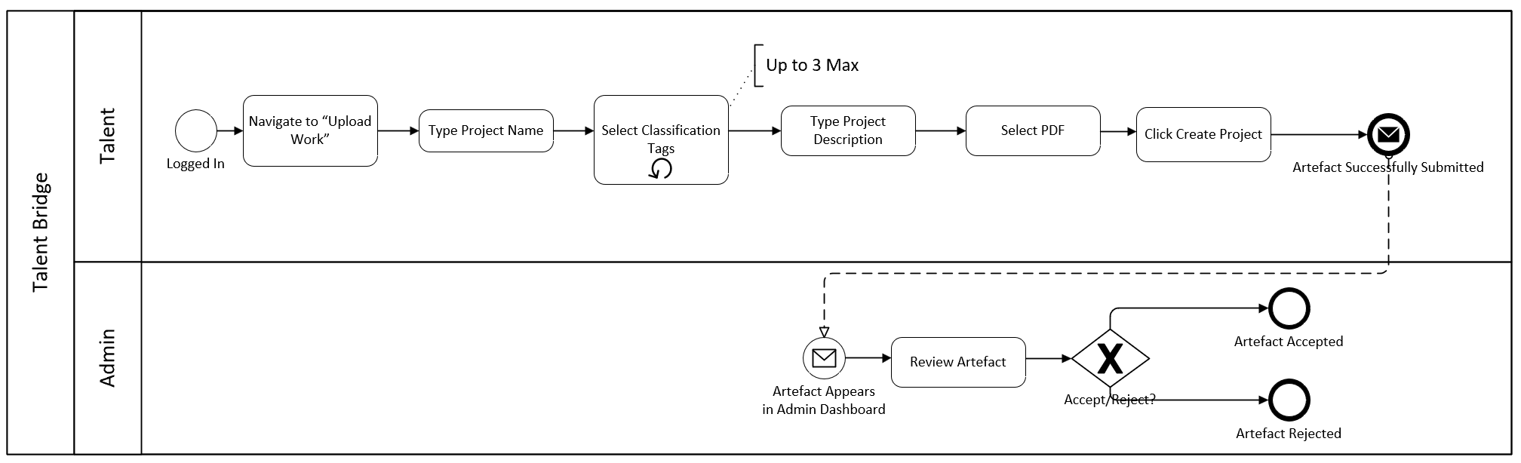
Figure D: BPMN – Process 3: Artifact Upload & Verification

5.4 Process 4: Recruiter Discovery & Interest
Process Description:
- The process starts with Recruiter already logged in and wanting to browse for a candidate/talent.
- Recruiters will search by typing and can choose to apply classification, either way, they will be presented with the result accordingly.
- After they have browsed and selected a project, the recruiter will click the “interested” button to send the talent an invitation to reach out.
- Talent will receive the notification on their homepage and will receive the details of the recruiter.
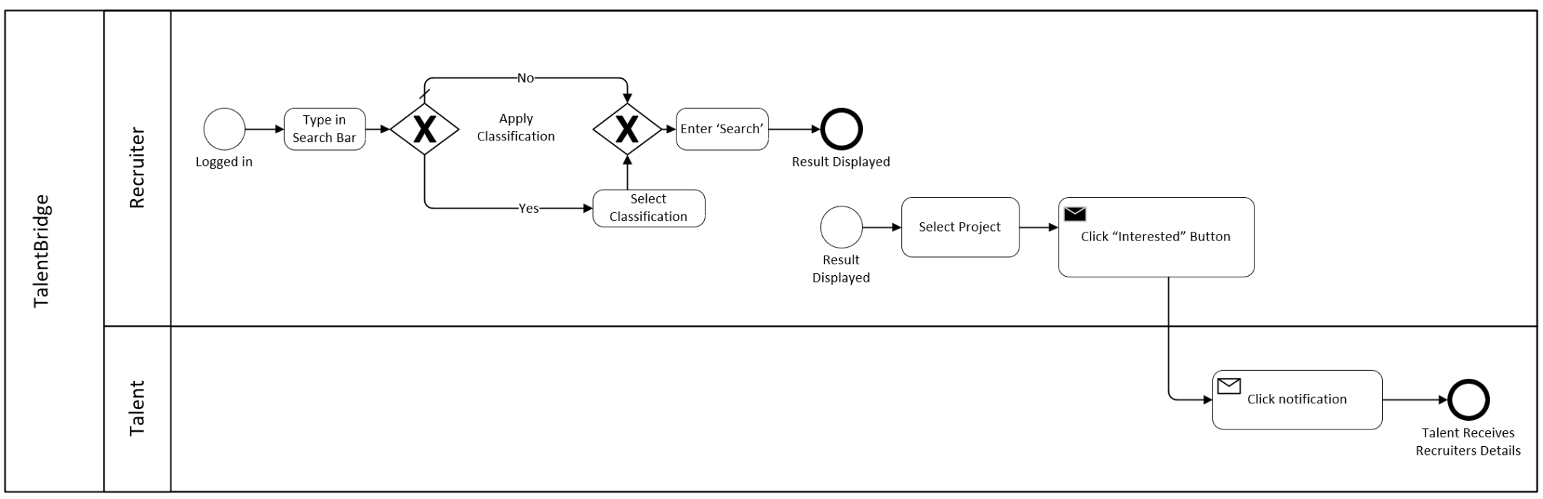
Figure E: BPMN – Process 4: Recruiter Discovery & Interest

6. User Interaction Design (Wireframes)
The wireframes below illustrate the screen-level interaction design for the PAIR platform. Wireframes represent the intended layout and user flow for each key screen, supporting the functional requirements defined in the BRD. The interaction design follows usability principles for web-based platforms as described by Nielsen & Molich (1990), prioritising clarity, consistency, and error prevention.
6.1 New User Screens
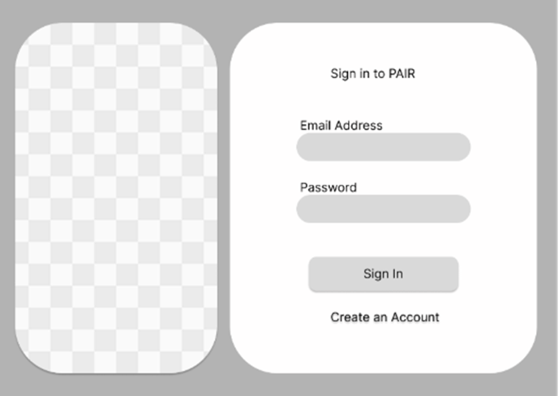
Figure 1: Login Page – Users can either log in or create a new account
The login page provides users with the option to sign in using their registered email and password, or to authenticate via Google OAuth 2.0. A "Create an Account" link is available for new users.
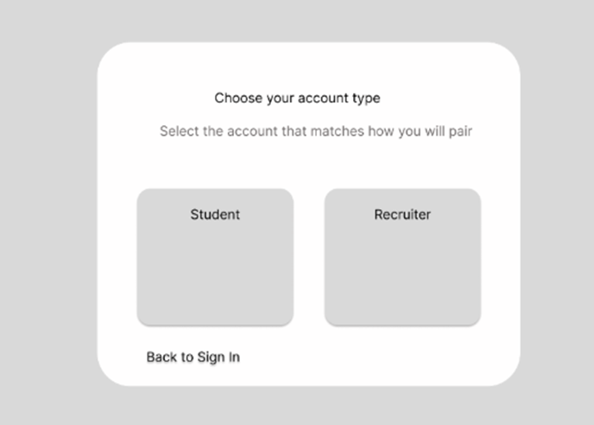
Figure 2: User selects the account type
Upon choosing to create a new account, the user is prompted to select their account type: Student (Talent) or Recruiter. This selection determines the registration form and dashboard the user will be directed to.

User Profile Creation
The platform allows users to create a profile. If the user has an existing profile, they will input their email and password to log in to their homepage. If the user is new, they can create an account by clicking "Create an Account".
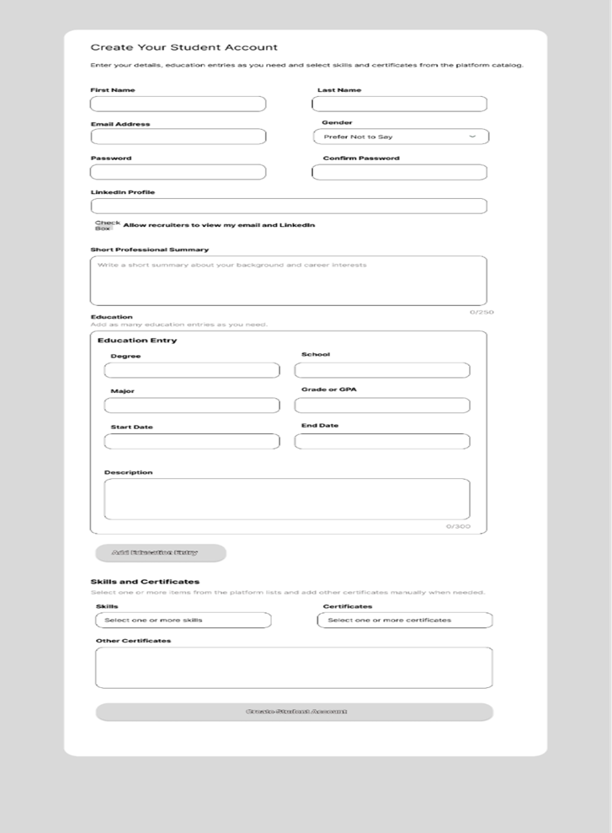
Figure 3: Talent Account Creation Form
The talent registration form collects personal information e.g., education details, skills (tag-based), and optional certifications. All mandatory fields must be completed before the account can be created.
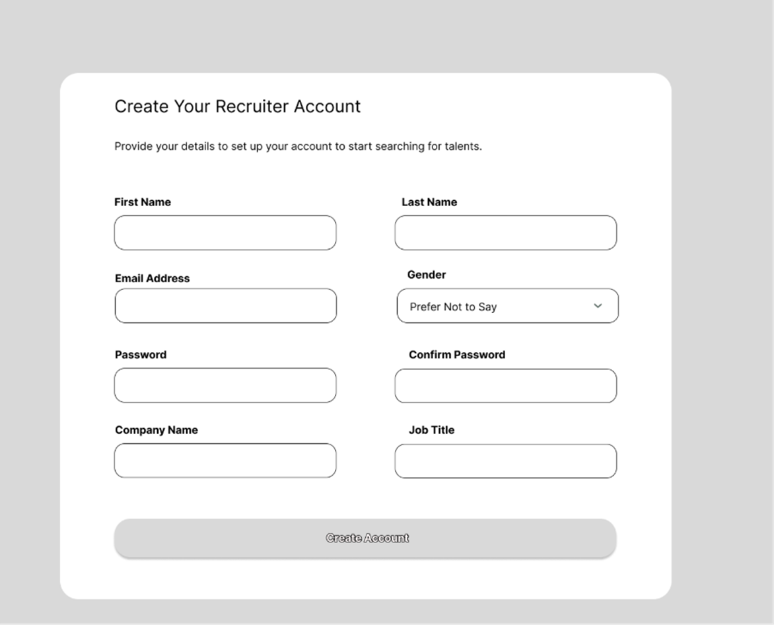
Figure 4: Recruiter Account Creation Form
The recruiter registration form collects contact information, company name, and job title. All mandatory fields must be completed. An email is sent to the user's registered address to confirm account creation.
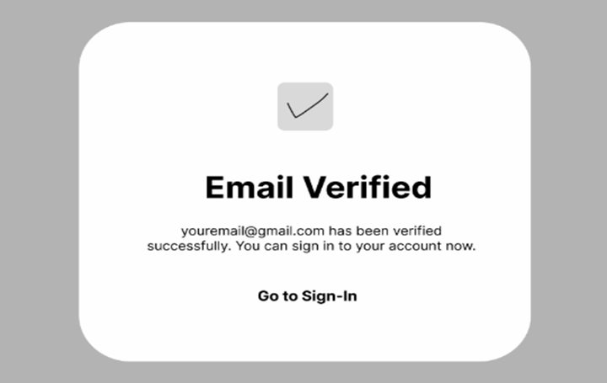
Figure 5: Email Verification Confirmation
A confirmation message is displayed after the user verifies their email address, confirming successful account creation and directing the user to sign in.

After verification, users land on their homepage depending on how they signed up.
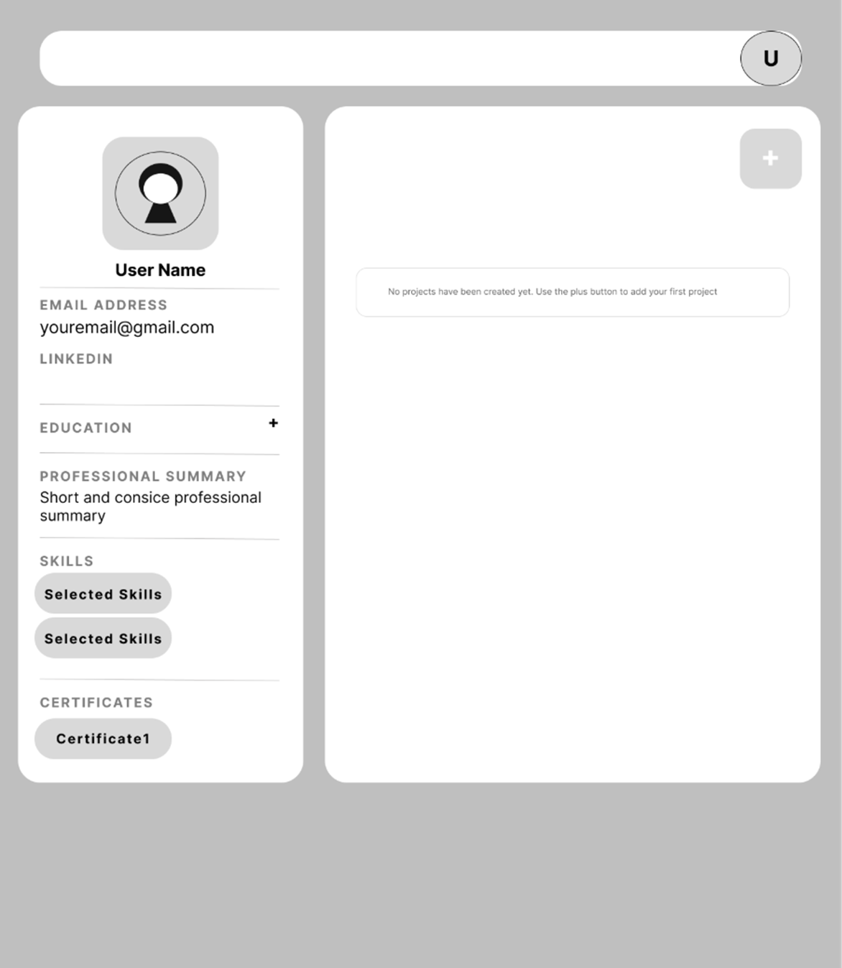
Figure 6: Talent's Default Homepage
The talent homepage displays the user's profile summary, uploaded project artifacts, and quick-access options for uploading new work or editing their profile.
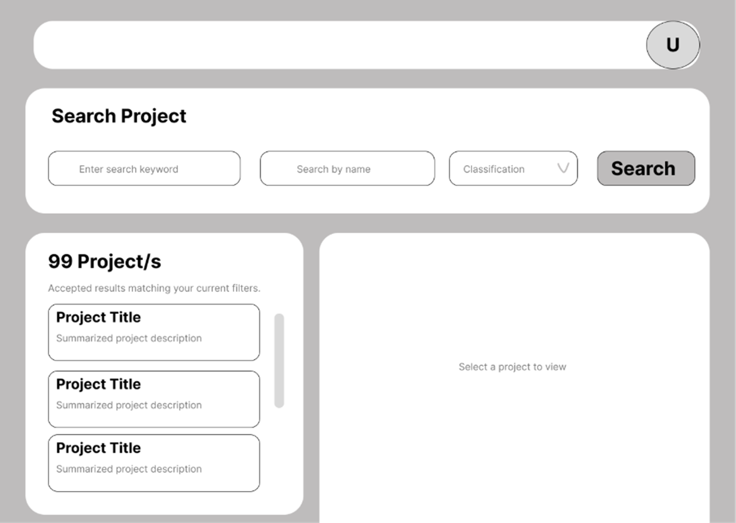
Figure 7: Recruiter's Home Page
The recruiter homepage features the project search interface, including keyword search, classification filter, name filter, and favorites filter. Search results are displayed as a list of project cards.

Upload Work
The talent starts to upload their work by clicking on the highlighted upload button.
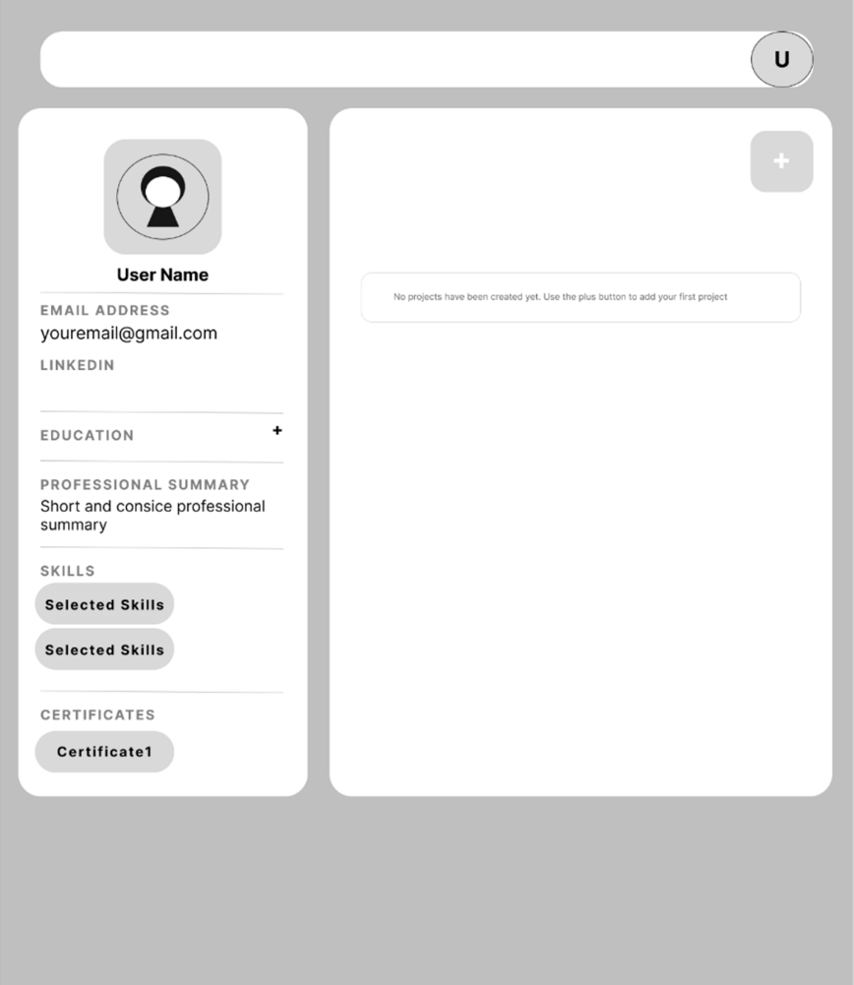
Figure 8: Talent Uploading Work – Step1

The talent navigates to the upload section from their homepage by clicking the designated upload button.
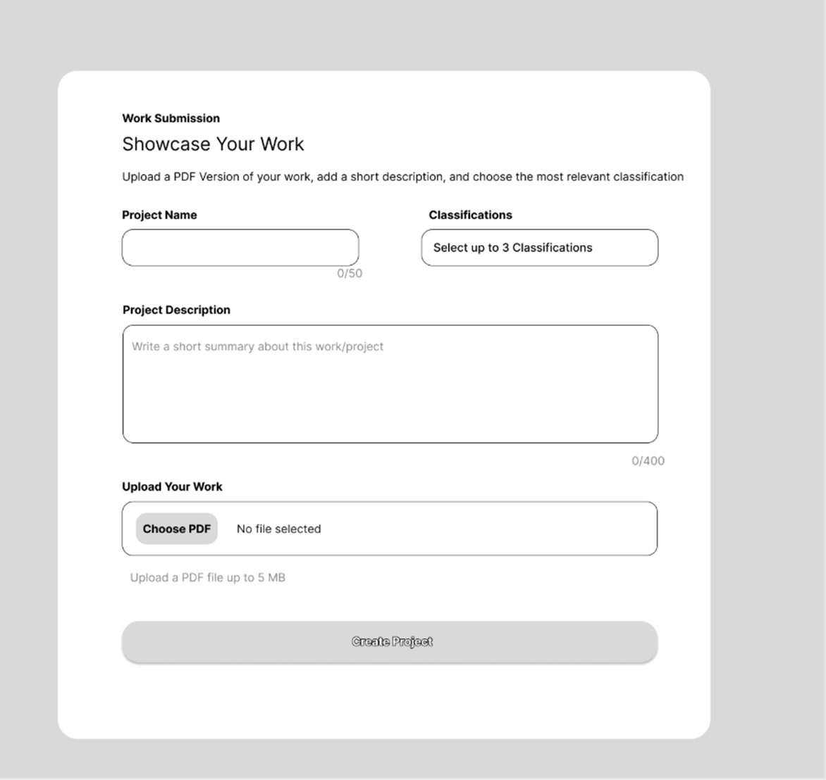
Figure 9: Talent Inputs Details for Their Project – Step 2
The talent fills in the project details form, including project name, description, classification category, and uploads a PDF artifact. Only PDF files are accepted. The form validates all required fields before submission.

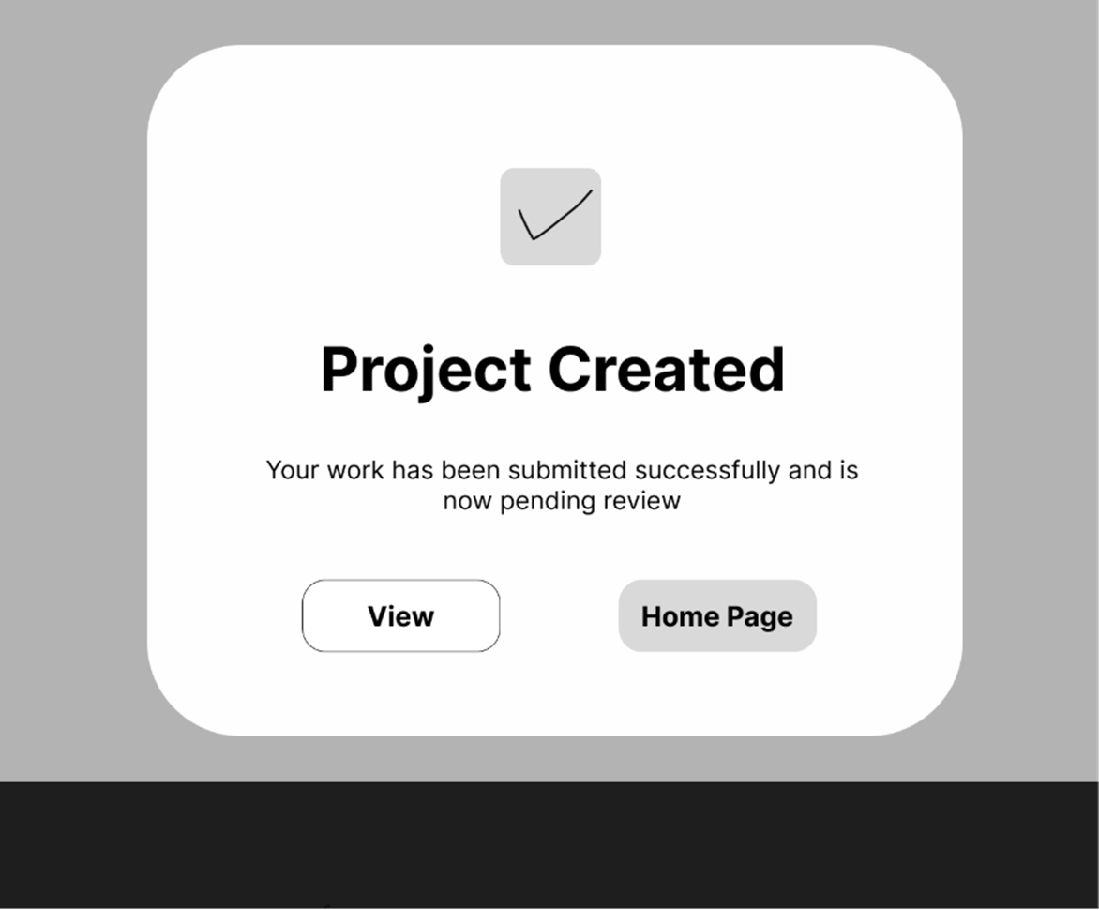
Figure 10: Verification Message – Project Creation Confirmed
A confirmation message is displayed upon successful project submission, notifying the talent that their artifact has been submitted and is now pending admin verification.
Approval of Work / Project
The admin dashboard displays all artifacts with "Pending Verification" status. The admin can open each artifact, review the PDF content, and click either "Approve" or "Reject". Approved artifacts receive a "Verified" badge and become visible in recruiter searches. Rejected artifacts remain in the archive under a "Rejected" label.

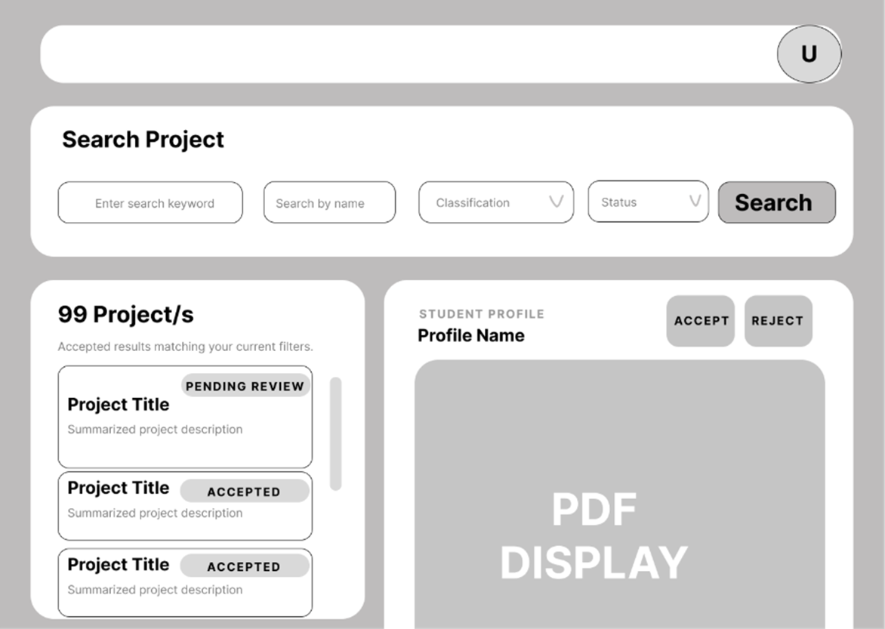
Figure 11: Admin’s Dashboard
Recruiter Search for Profile / Project
Once artifacts are approved, they appear in the recruiter's search results. Recruiters can search by keyword, filter by classification category, name, or favorites status to discover relevant talent.
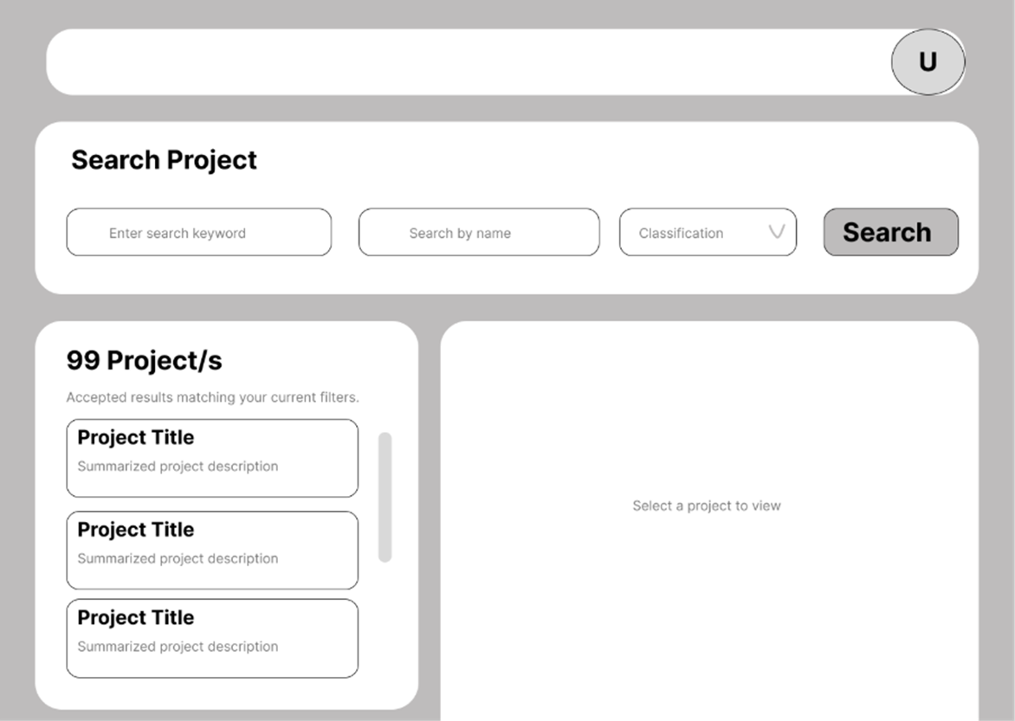
Figure 12: Recruiter's Homepage Updated with Projects Approved

Edit Profile
Users can manage their profile by hovering their mouse over their account icon. They can edit details, change email, and even delete their account.
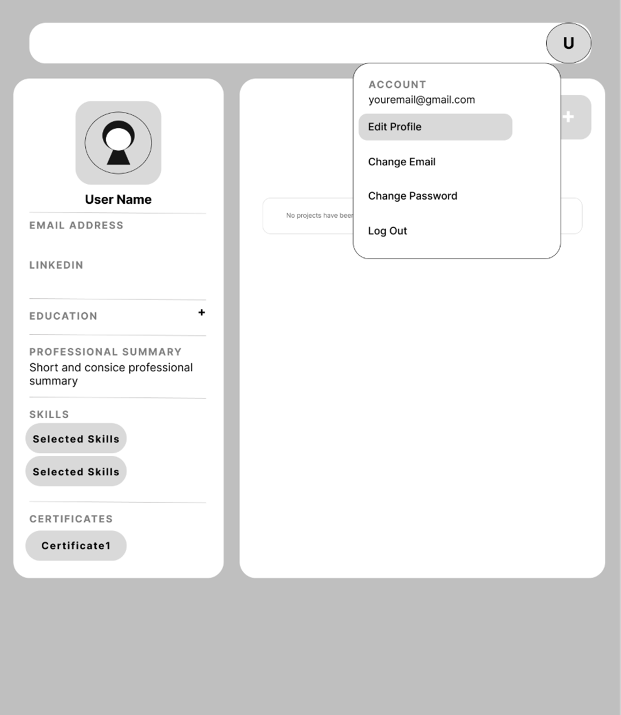
Figure 12: Account Management – Accessed by Hovering on Account
Hovering over the account icon reveals a dropdown menu with options to edit profile, change email, and delete account.
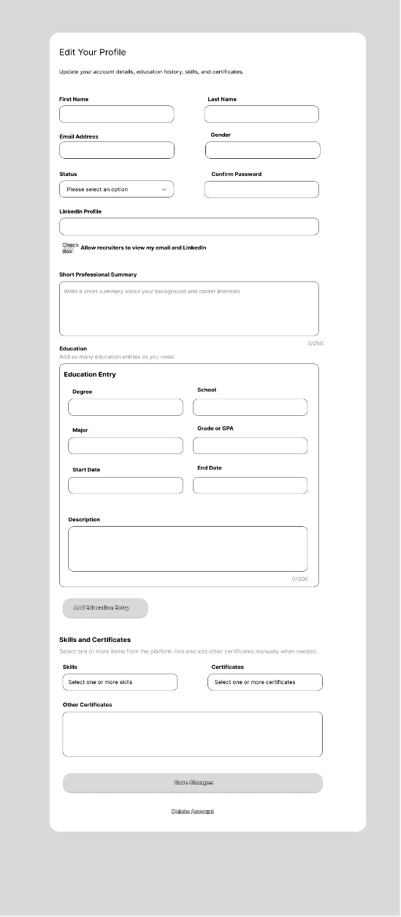
Figure 13: User is Led to the Page Where Changes Can Be Made
The edit profile page allows users to update personal details, education, skills, professional summary, and certifications. Changes are saved by clicking "Save Change", and a confirmation message is displayed.

Delete Profile
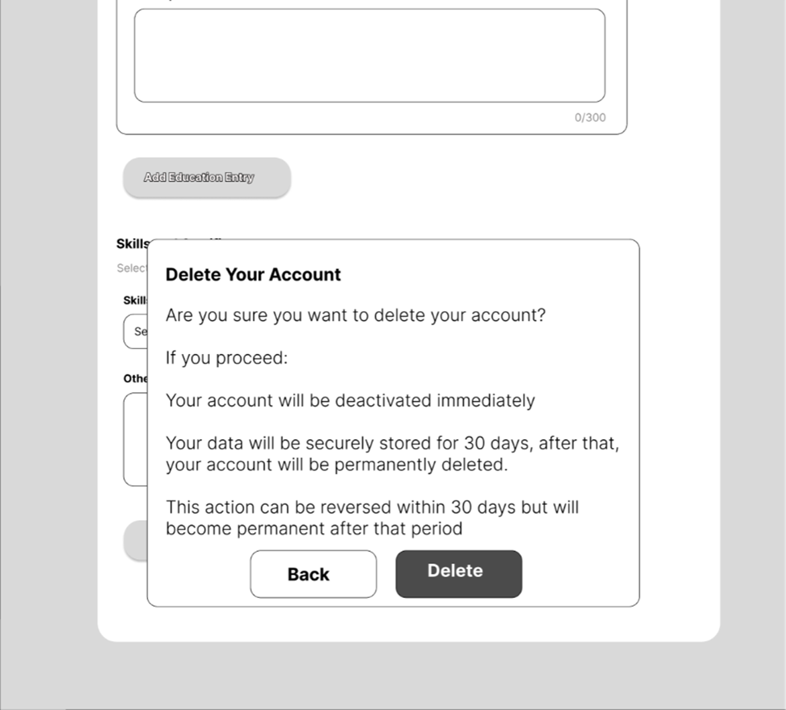
Figure 14 (Delete Account): Account Deletion Warning
When a user selects "Delete Account", a warning message is displayed explaining that account data will be retained for 30 days before permanent deletion, in accordance with FR1.7. The user must confirm the action before deletion proceeds.

Recruiters Connect with Talent
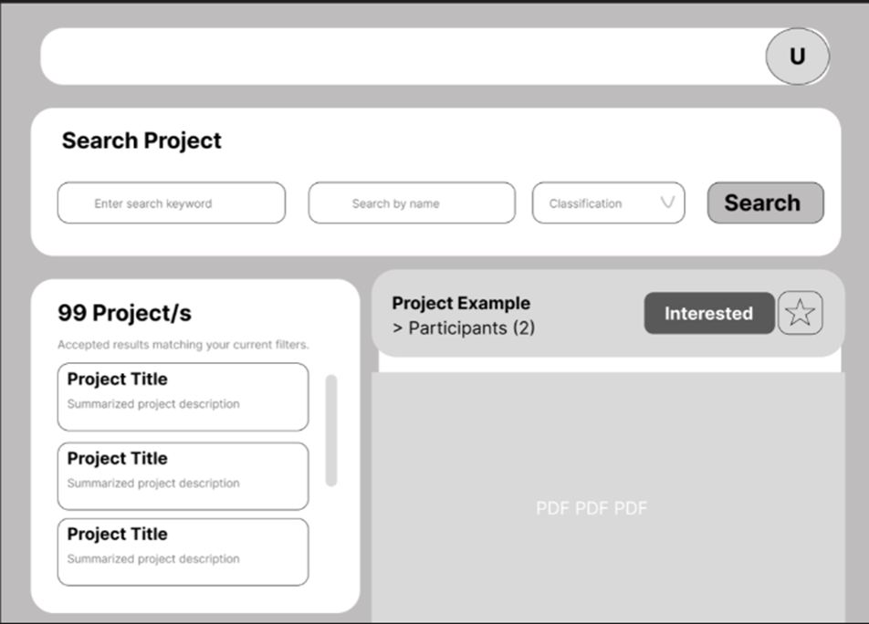
Figure 14: Recruiters Click the "Interested" Button After Reviewing a Project
From the project detail view, the recruiter can click the "Interested" button to express interest in the talent. A star-shaped button is also available to save the project as a favourite.

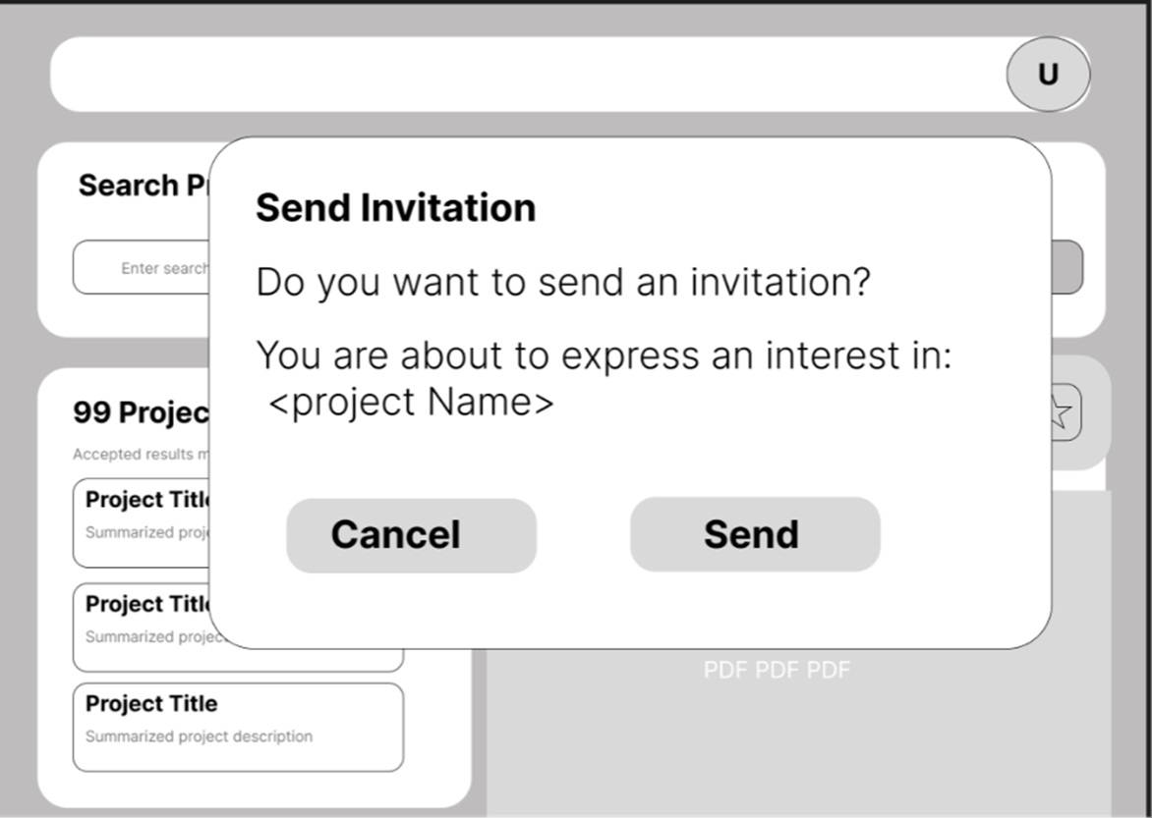
Figure 15: Confirmation Dialogue Box
A confirmation dialogue box is displayed to ensure the recruiter's decision before the interest action is recorded and the notification is sent to the talent.

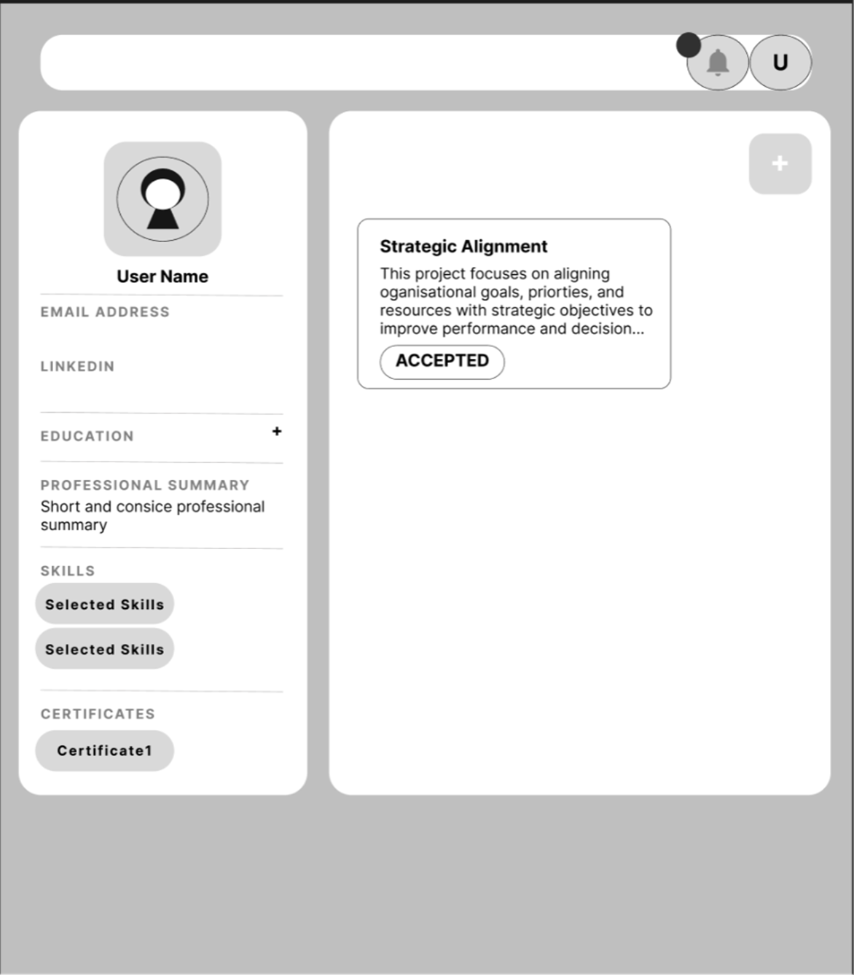
Figure 16: Talent Receives a Notification
The talent's notification interface displays a new notification triggered by the recruiter's "Interested" action, including the recruiter's name, company name, email, and timestamp.
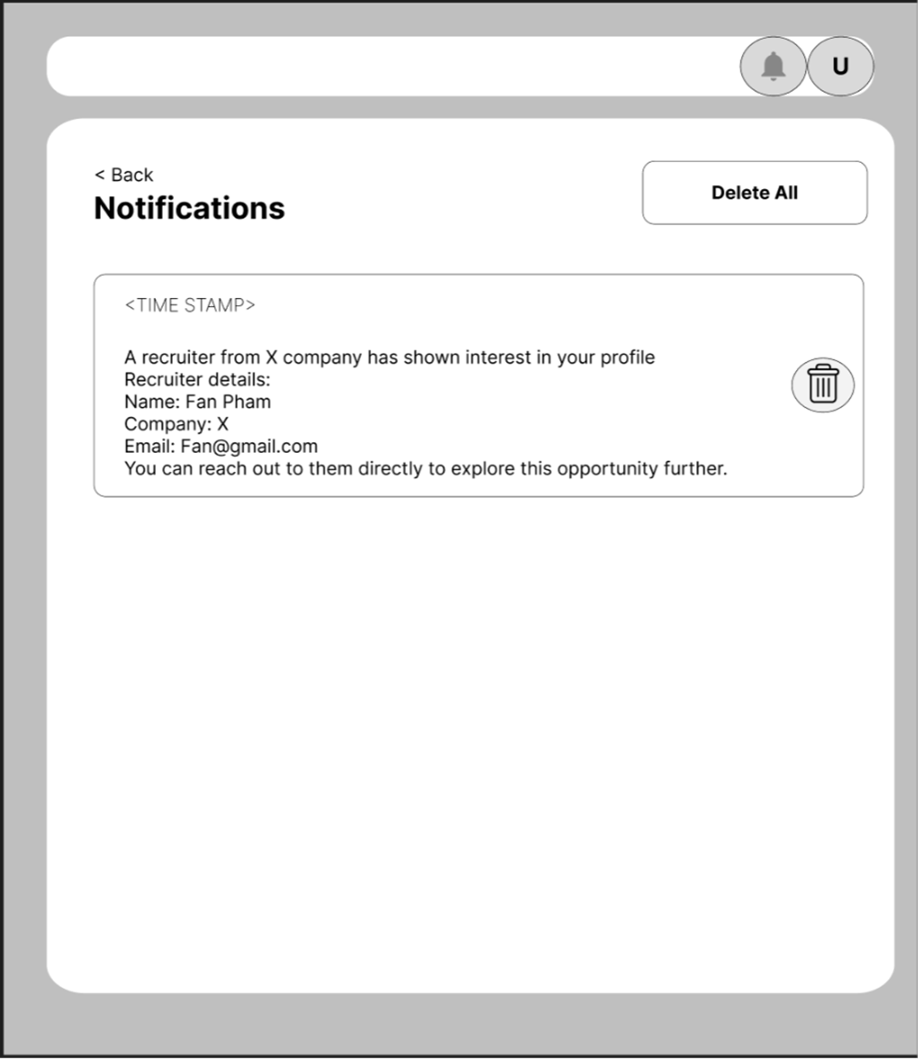
Figure 17: The Talent Can Then Decide to Email the Recruiter
The talent can view the recruiter's contact details within the notification (based on their privacy settings) and decide whether to follow up by email.

7. Design Rules and Behaviour
The following design rules govern system behaviour across all user interactions:
Rule | Description
Verified Artifacts Only | Only artifacts that have been approved by Admin are visible to recruiters in search results.
PDF Format Only | PDF is the only permitted artifact file format. All other file types are rejected with an appropriate error message.
No Duplicate Interests | Duplicate "Interested" actions from the same recruiter to the same talent are blocked by the system.
Contact Visibility Control | Talent contact details (email and LinkedIn) are shown or hidden based on the talent's individual privacy settings.
Participant Limit | A maximum of 7 participants per project, including the project owner, is enforced by the system.

References
Bass, L., Clements, P., & Kazman, R. (2012). Software architecture in practice (3rd ed.). Addison-Wesley.
Nielsen, J., & Molich, R. (1990). Heuristic evaluation of user interfaces. In Proceedings of the ACM CHI'90 Conference (pp. 249–256). ACM Press.
OMG. (2011). Business process model and notation (BPMN) version 2.0. Object Management Group. https://www.omg.org/spec/BPMN/2.0/

